**Objective:**  To win and make many dollars so I can live a relaxed life by a pool drinking beers in the carribean.

**Education:** I go to Yale as a liberal Arts Major

**Strengths:** Trilingual-Fluent in German, English, and Spanish

Technology  
-Computer programming in multiple languages with the ability to learn a new

concept/language very quickly(Java, Basic 6.0, Assembly)  
-Can fix most complex computer problems

-Skilled at software and hardware maintenance

-Possess ability to Solder  
-Years of experience fixing personal computers, electronics, and home networks  
-Great skill with computers or electronics hardware

Mathematical  
 -Great mathematical skill up to and beyond Calculus 2

Interpersonal  
 -Great with teams  
 -Very skilled at conveying complex information in a simple form

-Years of Customer Service jobs

Worker  
 -Follows instructions well, especially when copy/pasting and deleting a resume for comedic reasons.

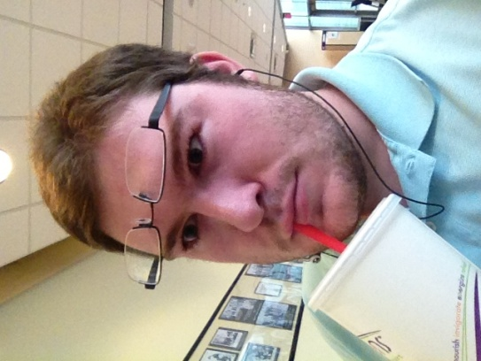**I’m 20, my last name is terrible to pronounce as an American. Here’s some phonetic: Aang – el – mai – uh(r).**